**Java Sample S1 2022 (provided by Monash)**

**Question 1**

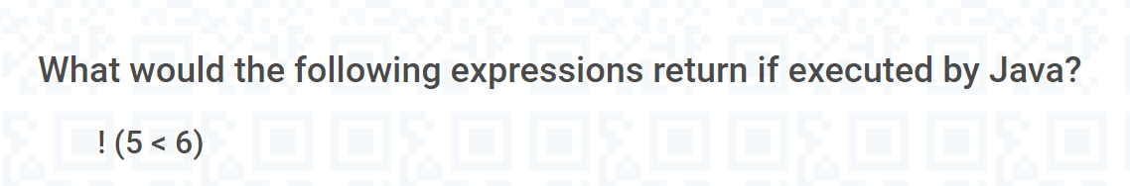

false

**Question 2**

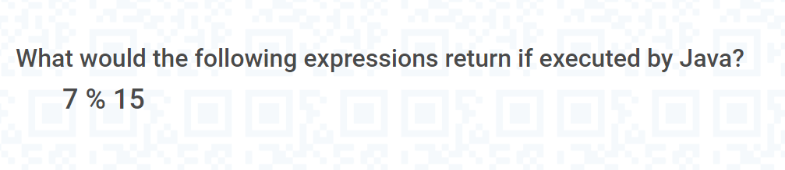

**7**

**Question 3**

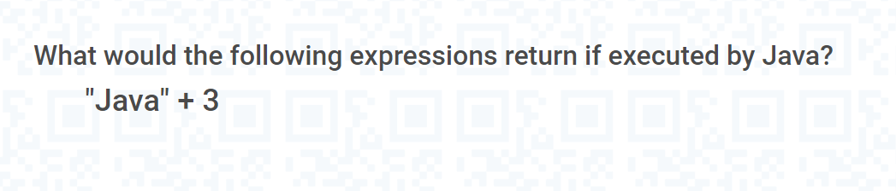

java3

**Question 4**

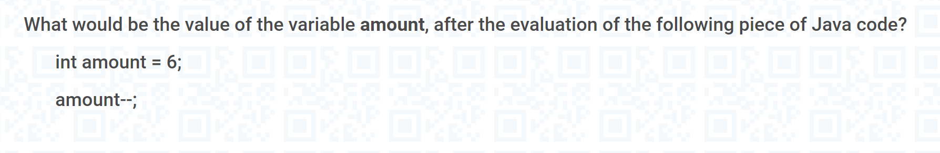

5

**Question 5**

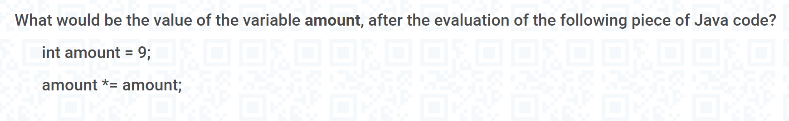

**81**

**Question 6**





**A: private ArrayList<Student> tutorialGroup;**

**Q1: How to initial it in the default constructor?**

**public ArrayListConstructorDemo()**

**{**

**String string = "null";**

**list = new ArrayList<String>();**

**}**

**Q2: How to init in the non-default constructor?**

**public ArrayListConstructorDemo(String string,List<String> list)**

**{**

**this.string = string;**

**this.list = list;**

**}**

**Q3: If we already init it in the default and non-default constructor, if we can assign a new value in the method as well? (e.g : tutorialGroup = new ArrayList<>();**

**Question 7**

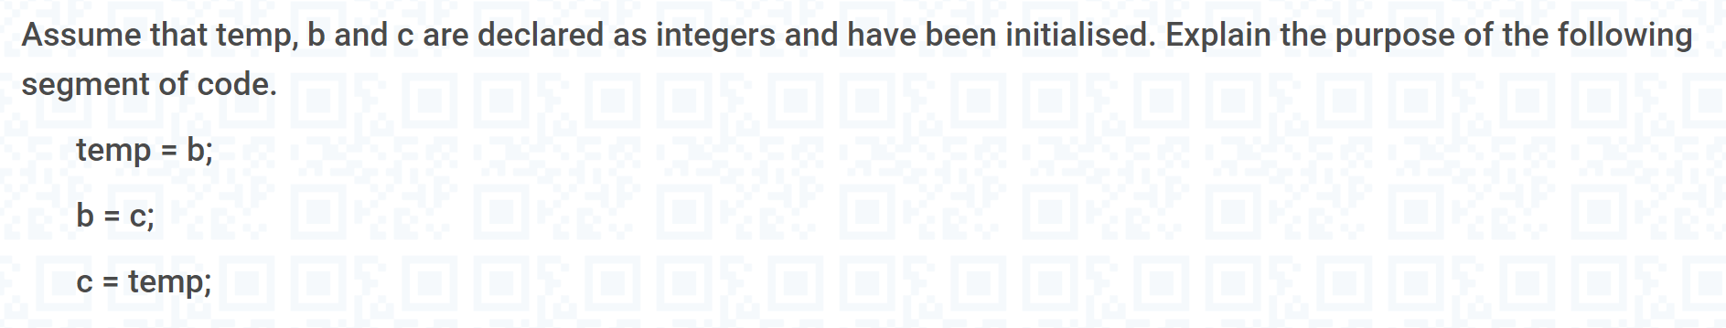

**Swap b c value**

**Question 8**

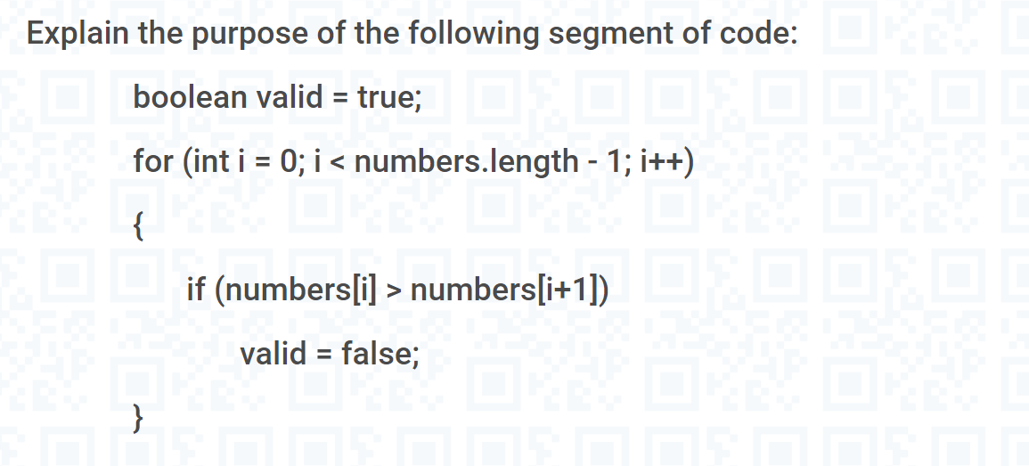



**Question 9**

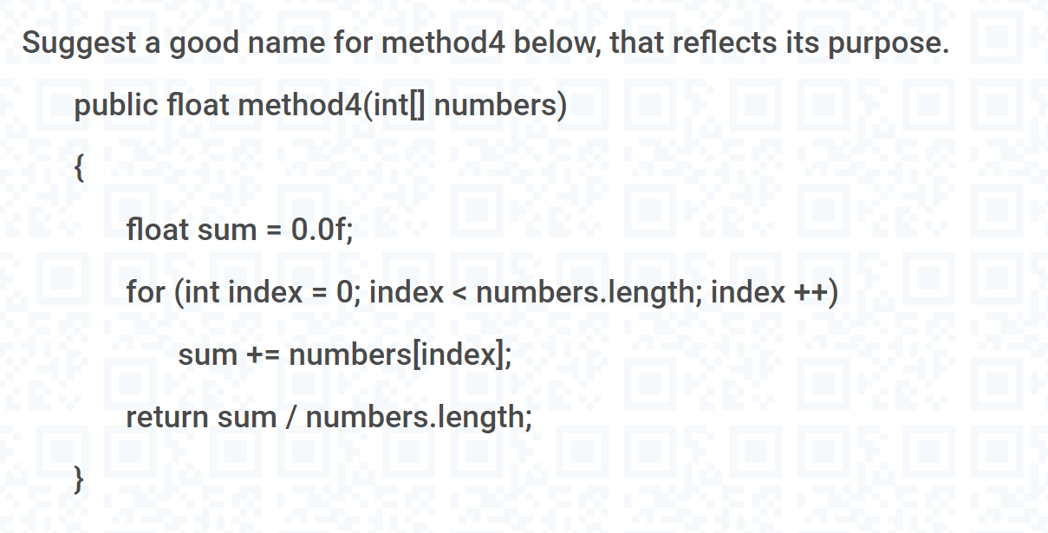

**listAverageNum**

**Question 10**

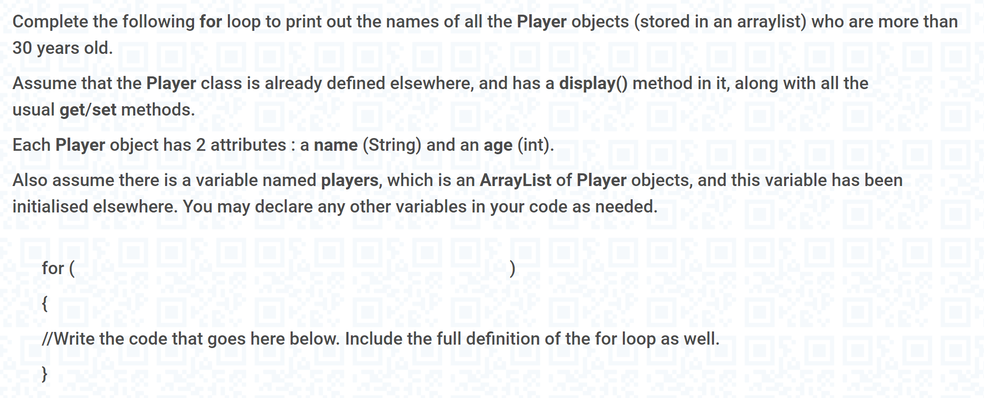

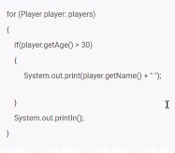

for (int i = 0; i< players.size(); i++)

{

if (players.get(i).getAge() > 30)

System.out.println(players.get(i).getName());

}

//another way

for (Player player : players )

{

if (player .getAge() > 30)

System.out.println(player.getName());

Q1: What is the difference between array and arraylist?

Q2: What is the difference between for loop and for-each loop, as for-each loop has less

code as for loop, why we need for loop as well? (index / id)

3. for each loop /while /for loop，4种loop的写法，必要时候掌握迭代iterator的写法

// create an array

int[] numbers = {3, 9, 5, -5};

// for each loop

for (int number: numbers) {

System.out.println(number);

}

int i = 0;

while (i < 5) {

System.out.println(i);

i++;

}

for (statement 1; statement 2; statement 3) {

// code block to be executed

}

Statement 1 is executed (one time) before the execution of the code block.

Statement 2 defines the condition for executing the code block.

Statement 3 is executed (every time) after the code block has been executed.

**Question 11**



public String getLongestString(String[] array) {

String longest = array[0];

for (int i=1; i<array.length; i++) {

if (array[i].length() > longest.length()) {

longest = array[i];

}

}

return longest;

}

**Question 12**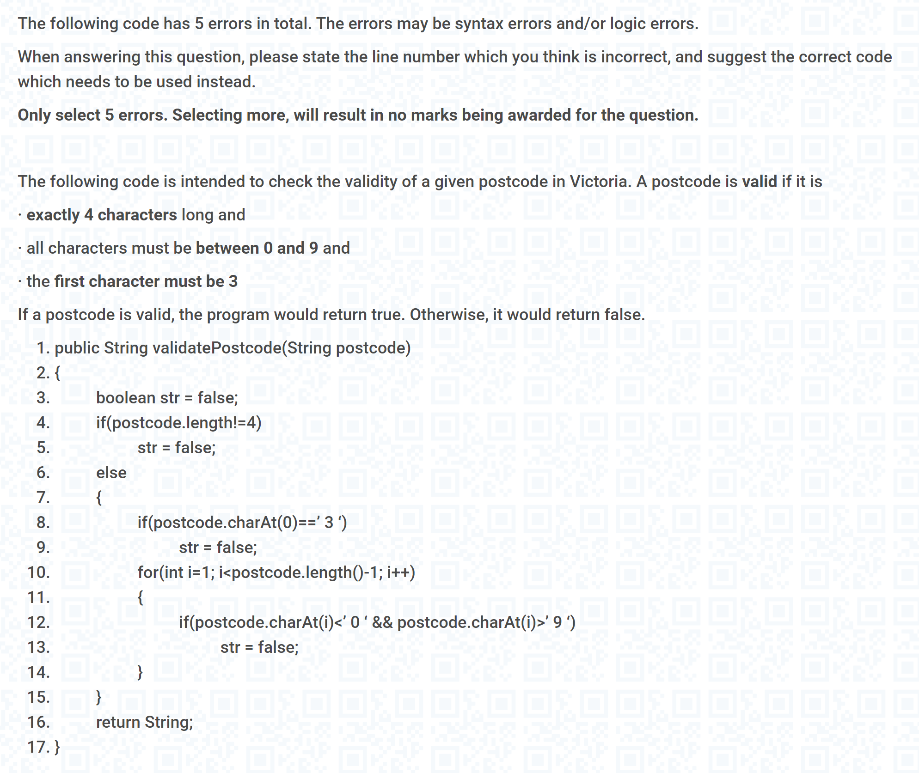

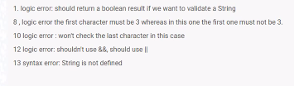

**Question 13**

Check the content on ed platform - mock exam S1 2022.

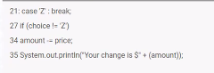

Line 21: case’Z’: break;

Line 25: while(choice != ‘Z’ && amount < price); -> 2 errors corrected

Line 27: if(choise != ‘Z’)

Line 14: choice = console.nextLine().charAt(0)

Line 21: remove case’Z’

Line 25: while(choice != ‘Z’ || amount <= price);

TBD